Name: Madhurya Mozumder

Reg. Number: RA1911028010036

Section: CSE-CC I2

**EXPERIMENT 1**

**Aim:** To do a lexical analysis on a given portion of code

**Procedure:** The code for lexical analysis has been written in C language and run on a compiler.

**Code:**

#include <stdbool.h>

#include <stdio.h>

#include <string.h>

#include <stdlib.h>

bool isValidDelimiter(char ch) {

if (ch == ' ' || ch == '+' || ch == '-' || ch == '*' ||

ch == '/' || ch == ',' || ch == ';' || ch == '>' ||

ch == '<' || ch == '=' || ch == '(' || ch == ')' ||

ch == '[' || ch == ']' || ch == '{' || ch == '}')

return (true);

return (false);

}

bool isValidOperator(char ch){

if (ch == '+' || ch == '-' || ch == '*' ||

ch == '/' || ch == '>' || ch == '<' ||

ch == '=')

return (true);

return (false);

}

// Returns 'true' if the string is a VALID IDENTIFIER.

bool isvalidIdentifier(char* str){

if (str[0] == '0' || str[0] == '1' || str[0] == '2' ||

str[0] == '3' || str[0] == '4' || str[0] == '5' ||

str[0] == '6' || str[0] == '7' || str[0] == '8' ||

str[0] == '9' || isValidDelimiter(str[0]) == true)

return (false);

return (true);

}

bool isValidKeyword(char* str) {

if (!strcmp(str, "if") || !strcmp(str, "else") || !strcmp(str, "while") || !strcmp(str, "do") || !strcmp(str, "break") || !strcmp(str, "continue") || !strcmp(str, "int")

|| !strcmp(str, "double") || !strcmp(str, "float") || !strcmp(str, "return") || !strcmp(str, "char") || !strcmp(str, "case") || !strcmp(str, "char")

|| !strcmp(str, "sizeof") || !strcmp(str, "long") || !strcmp(str, "short") || !strcmp(str, "typedef") || !strcmp(str, "switch") || !strcmp(str, "unsigned")

|| !strcmp(str, "void") || !strcmp(str, "static") || !strcmp(str, "struct") || !strcmp(str, "goto"))

return (true);

return (false);

}

bool isValidInteger(char* str) {

int i, len = strlen(str);

if (len == 0)

return (false);

for (i = 0; i < len; i++) {

if (str[i] != '0' && str[i] != '1' && str[i] != '2'&& str[i] != '3' && str[i] != '4' && str[i] != '5'

&& str[i] != '6' && str[i] != '7' && str[i] != '8' && str[i] != '9' || (str[i] == '-' && i > 0))

return (false);

}

return (true);

}

bool isRealNumber(char* str) {

int i, len = strlen(str);

bool hasDecimal = false;

if (len == 0)

return (false);

for (i = 0; i < len; i++) {

if (str[i] != '0' && str[i] != '1' && str[i] != '2' && str[i] != '3' && str[i] != '4' && str[i] != '5' && str[i] != '6' && str[i] != '7' && str[i] != '8'

&& str[i] != '9' && str[i] != '.' || (str[i] == '-' && i > 0))

return (false);

if (str[i] == '.')

hasDecimal = true;

}

return (hasDecimal);

}

char* subString(char* str, int left, int right) {

int i;

char* subStr = (char*)malloc( sizeof(char) * (right - left + 2));

for (i = left; i <= right; i++)

subStr[i - left] = str[i];

subStr[right - left + 1] = '\0';

return (subStr);

}

void detectTokens(char* str) {

int left = 0, right = 0;

int length = strlen(str);

while (right <= length && left <= right) {

if (isValidDelimiter(str[right]) == false)

right++;

if (isValidDelimiter(str[right]) == true && left == right) {

if (isValidOperator(str[right]) == true)

printf("Valid operator : '%c'\n", str[right]);

right++;

left = right;

} else if (isValidDelimiter(str[right]) == true && left != right || (right == length && left != right)) {

char* subStr = subString(str, left, right - 1);

if (isValidKeyword(subStr) == true)

printf("Valid keyword : '%s'\n", subStr);

else if (isValidInteger(subStr) == true)

printf("Valid Integer : '%s'\n", subStr);

else if (isRealNumber(subStr) == true)

printf("Real Number : '%s'\n", subStr);

else if (isvalidIdentifier(subStr) == true

&& isValidDelimiter(str[right - 1]) == false)

printf("Valid Identifier : '%s'\n", subStr);

else if (isvalidIdentifier(subStr) == false

&& isValidDelimiter(str[right - 1]) == false)

printf("Invalid Identifier : '%s'\n", subStr);

left = right;

}

}

return;

}

int main(){

char str[100] = "int y = s * 2c % 42.78 ";

printf("The Program is : '%s' \n", str);

printf("All Tokens are : \n");

detectTokens(str);

return (0);

}

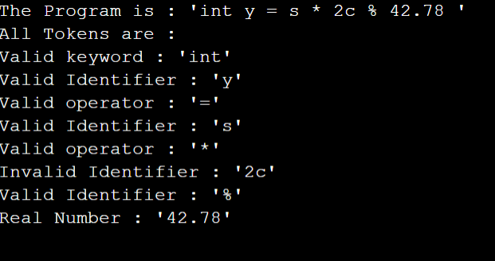**Output:**

**Result:** The program has been lexically analyzed and the Tokens have been printed.